AI ASSISTED CODING – 1

NAME : G.Harsha vardhan

HALLTICKET.NO : 2403A52313

BATCH.NO : 01

YEAR AND SEM : 2ND AND 3RD

>>use copilot to generate a is_prime() python function
Expected output#2
>>function to check primality with correct input
PROMPT:
>>Develop a python program to check a number prime or not
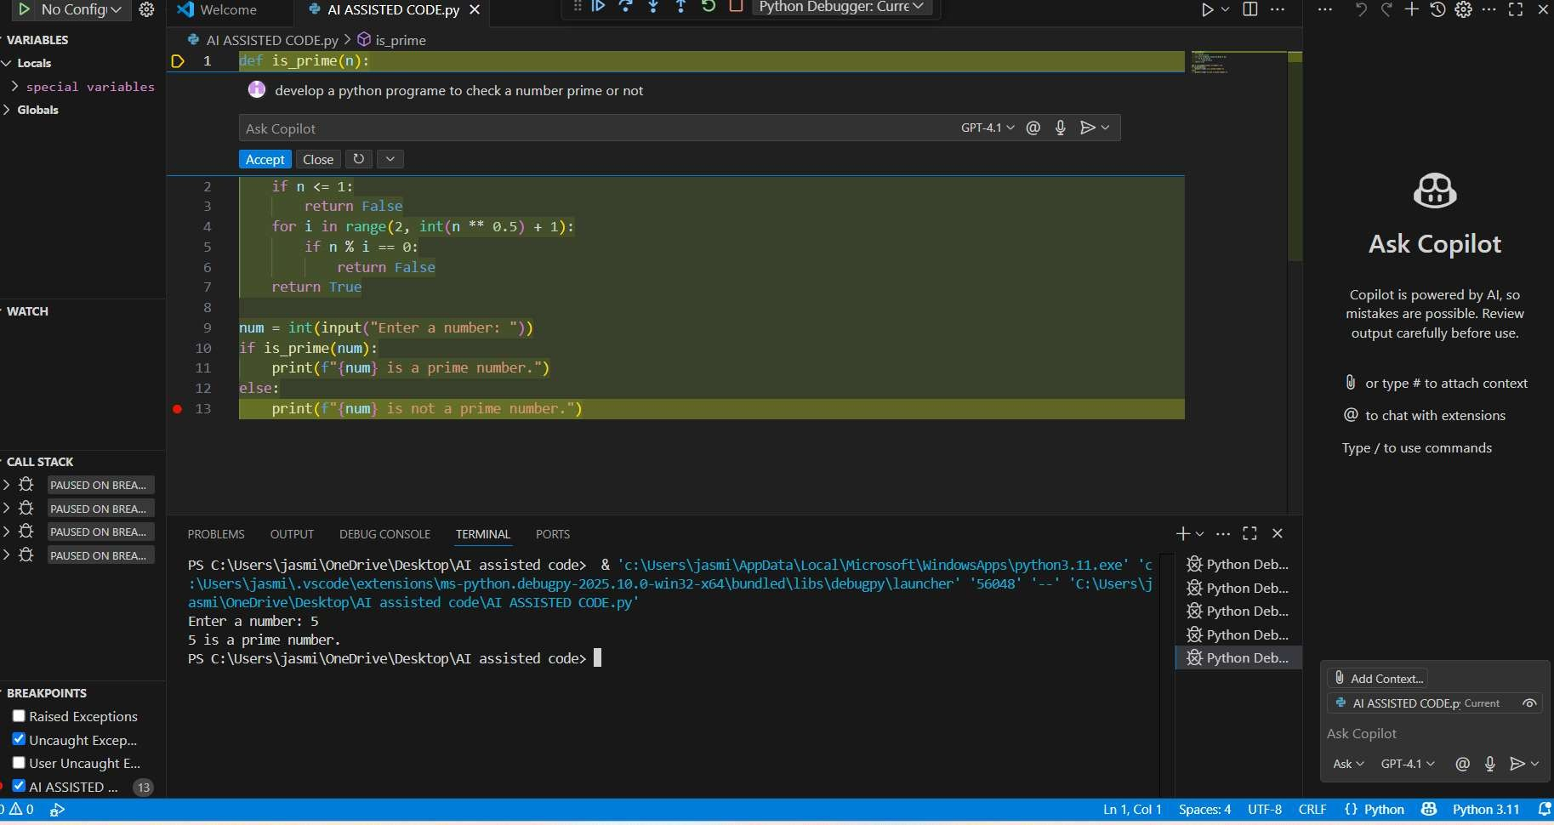

>>write a comment like#function to reverse a string and use copilot to generate a function Expected output#3 auto completed function PROMPT:
Develop a python code to generate a comment like#function to reverse a string
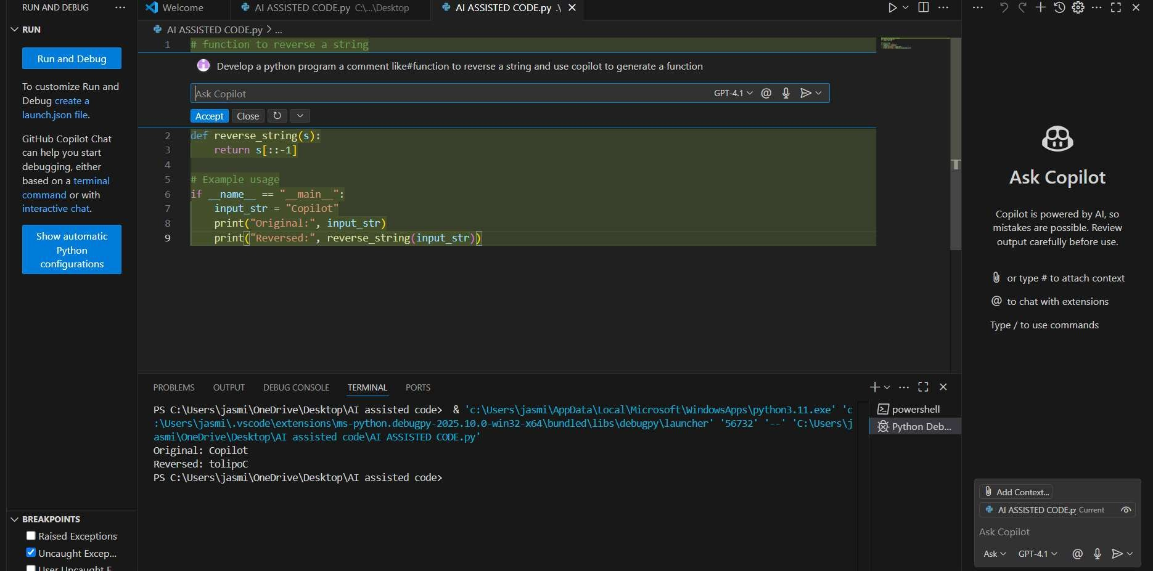

>>Generate both recursive and iterative versions of a factorial functions using comments
Expected output#4
>>two working factorial implementation PROMPT:
develop a python program to generate both recursive and iterative versions of a factorial functions using functions
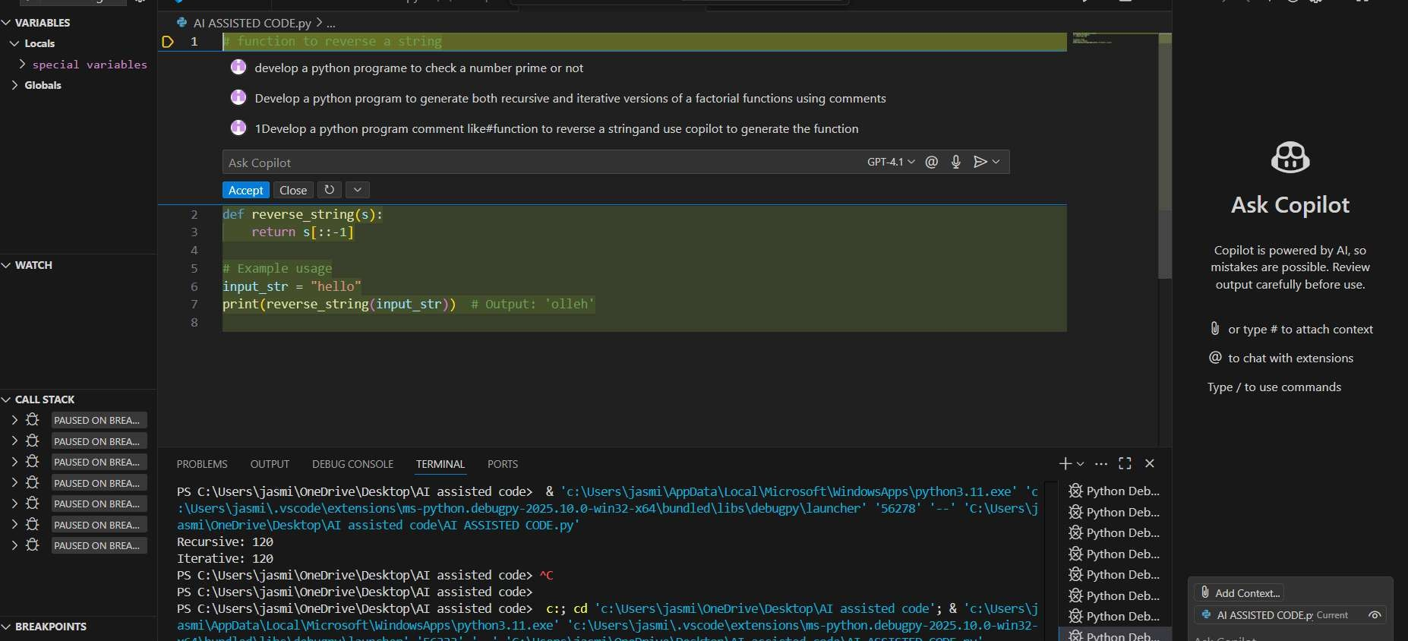

>>use copilot to find the largest number in a list assess code quality and efficiency Expected output#5
a valid function with your review PROMPT:
>>Develop a python program to find largest number in a list assess code quality and efficiency
